APHIS Figures

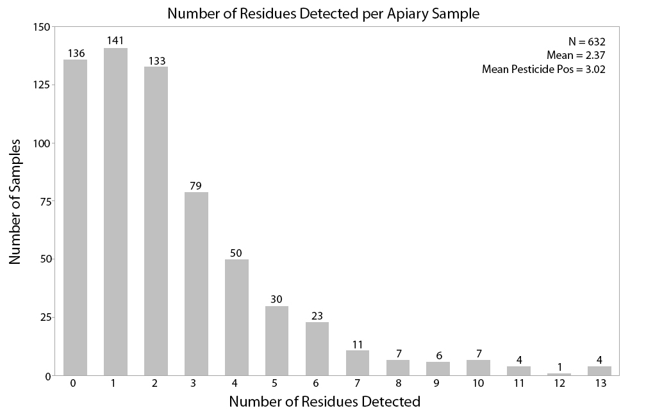

Fig. 1: Number of bee bread samples pooled from 8 colonies within a single apiary for the number of pesticide residues detected (0-13) with n indicated above bar. The majority of samples had 2 or fewer residues detected.

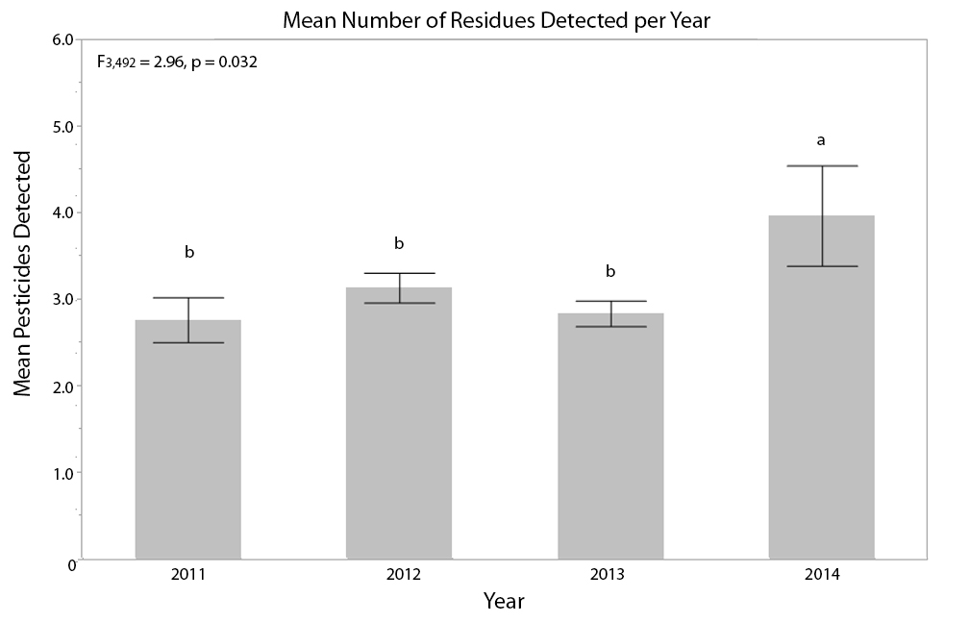

Fig. 2: Mean pesticide residues ± S.E. by sampling year for all samples that had at least one pesticide residue. Different letters indicate significant differences (α = 0.05).

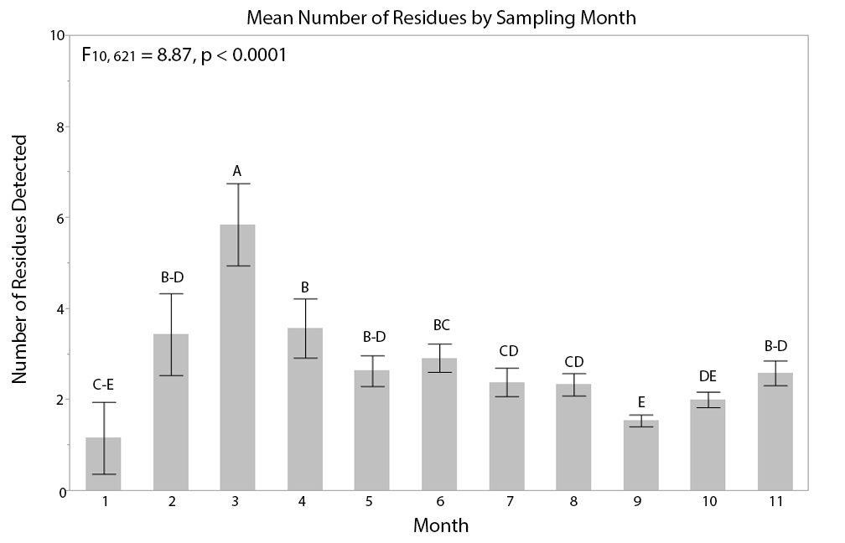

Fig. 3: Mean pesticide residues ± S.E. by sampling month for all samples. Different letters indicate significant differences (α = 0.05).

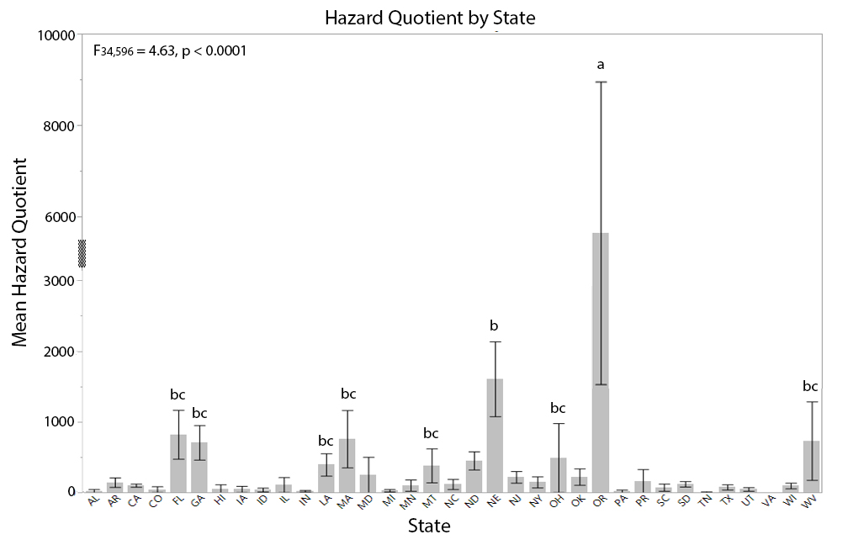

Figure 4: Mean HQ score ± S.E. by sampling state. The Y-axis breaks between 3,000 and 6,000 to depict the S.E. of Oregon (OR). Significant differences (α = 0.05) indicated by different letters; all unlabelled states are designated c.

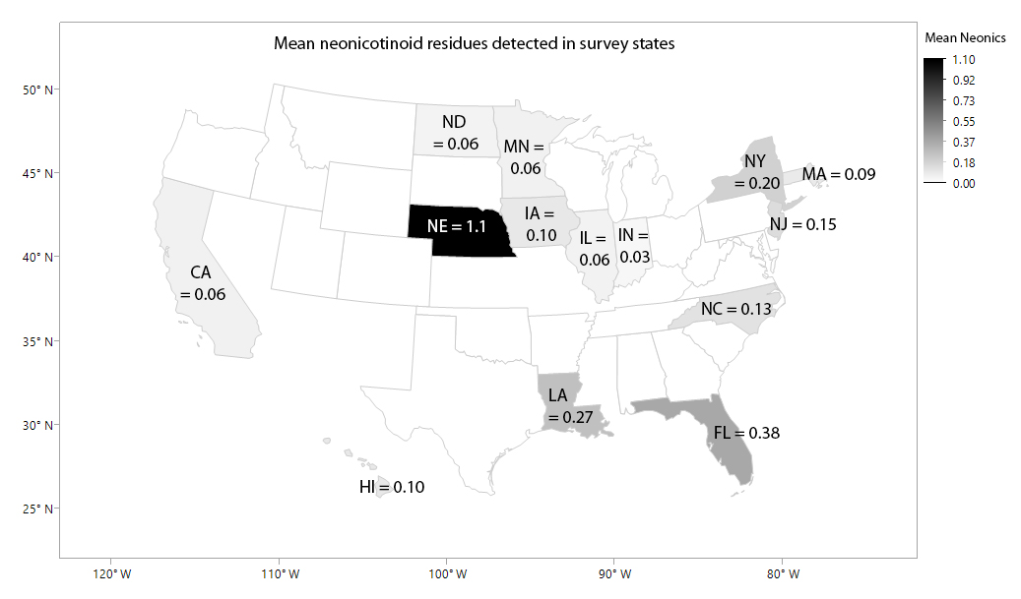

Fig. 5: Mean neonicotinoid residues detected per sample in survey states. Outlined state with no value did not have any detections.

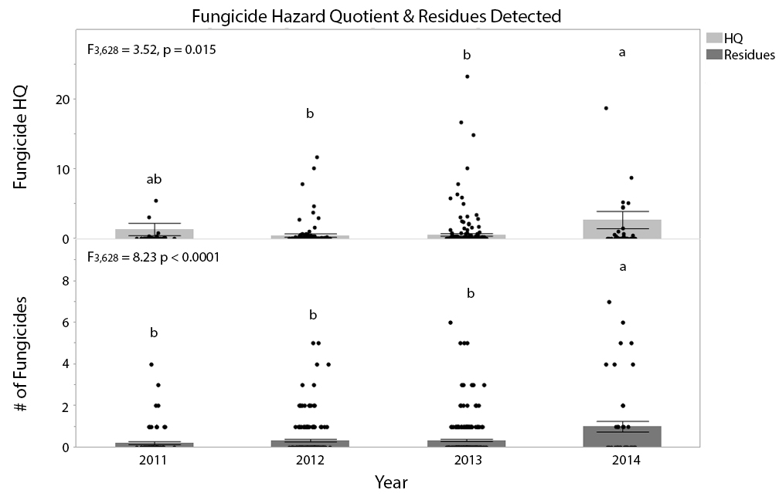

Fig. 6: Mean fungicide HQ ± S.E. (top) with all HQ scores below 30 shown; 1-2 additional outliers above 30 for each year and mean number of different fungicide residues detected ± S.E. (bottom)with individual samples shown as dots. Different letters indicate significant differences (α < 0.05).

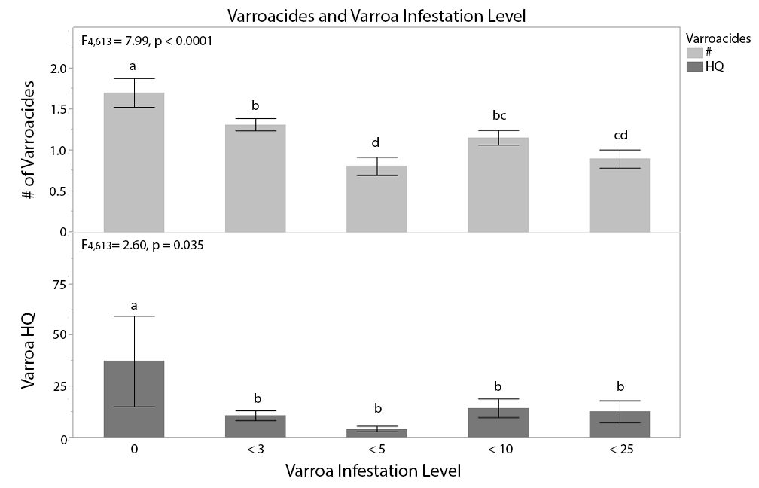

Fig. 7: Mean number of varroacides detected ± SE (top) and the mean points contributed to the HQ score by those varroacides ± SE (bottom).

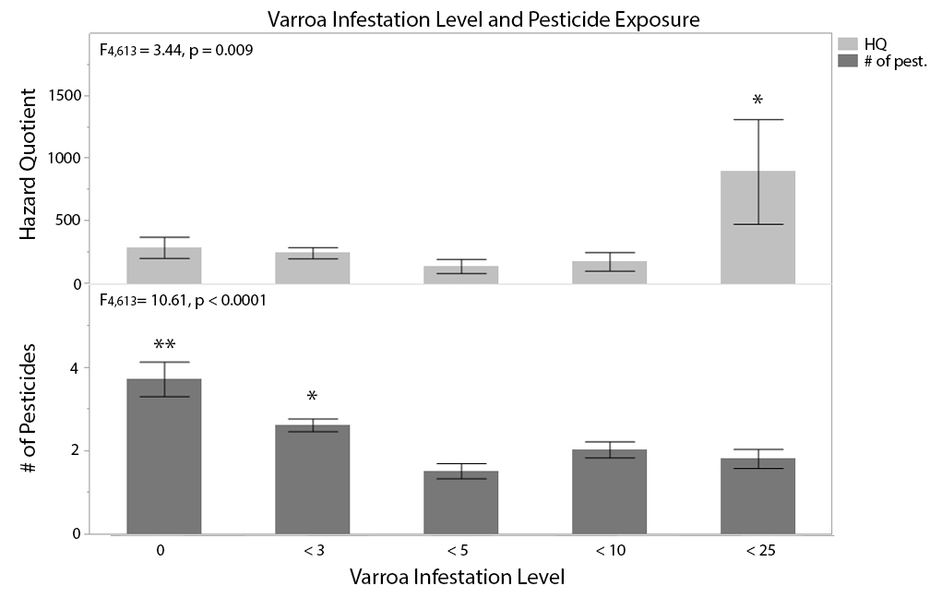

Fig. 8 *Varroa* infestation level and mean hazard quotient risk ± S.E. (top) and the mean number of pesticides detected ± S.E. (bottom).

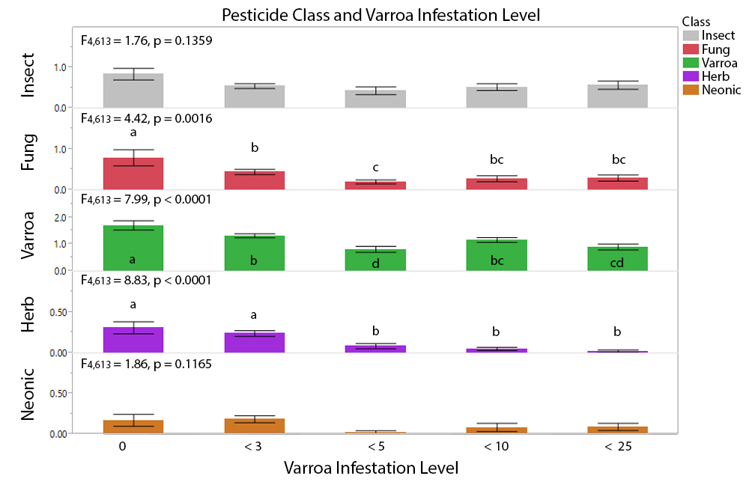

Fig. 9 Mean number of products detected ± S.E. for different pesticide classes. All varied significantly across *Varroa* infestation levels except for insecticides (top row) and neonicotinoids (bottom row).

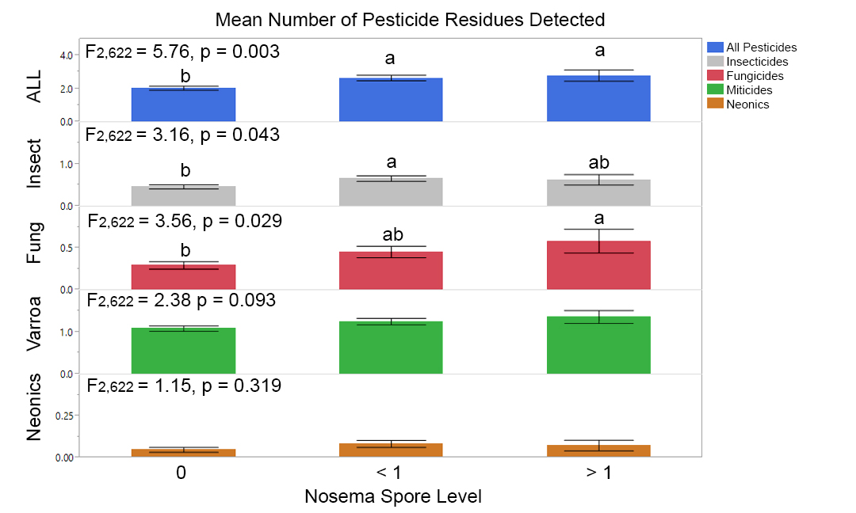

Fig. 10 Mean number of residues detected ± S.E. in samples with different *Nosema* spore levels. 0 = *Nosema* free samples; < 1 = samples with fewer than 1 million spores/bee, while > 1 = samples with more than 1 million spores/bee. Significant differences (α = 0.05) indicated by different letters. ALL = all pesticides detected; Insect = insecticides; Fung = fungicides; Varroa = varroacides; Neonics = neonicotinoids.